Protocol
(Detection of fullerene nanomaterials)

11/07/08 by Soryong Chae
Duke University

1. Standard curve
At the first step, a calibration curve must be created to measure fullerene concentrations. Fullerenes must be suspended in an organic solvent (toluene in this case) that will be used as the carrier fluid through the instrument column. Fullerene standards was prepared by adding different amounts of fullerene standard into 10 ml of toluene and sonicating for 1 h. Standards
were stored in amber vials at 4°C and allowed to come to room temperature before use. As shown in Figure 1, calibration curve for C60 ranged from 15 ppb to 15 ppm.

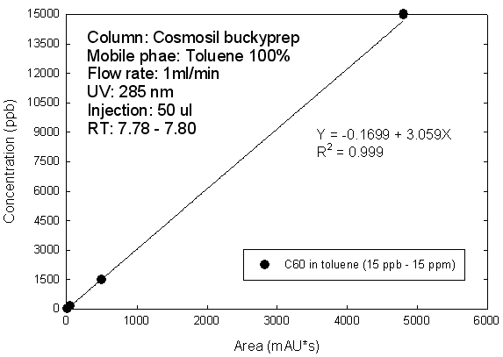
Figure 1. Detection of fullerene C60 in toluene by HPLC.

2. Sample extraction
If the fullerenes were originally suspended in a polar fluid (such as water) or , it is important to transfer them to the carrier fluid so that they will maintain their aqueous aggregate forms, rather then creating new fullerene suspensions in the carrier fluid.
A simplified liquid-liquid extraction (LLE) method was used to measure the C60 concentration in aqueous samples (without proteins or surfactants). C60 particles in aqueous colloidal solutions were negatively charged [1]. It is difficult to be extracted back into the toluene phase. Mild oxidants (e.g., Mg(ClO4)2) and electrolytes (e.g., KCl) have been used to destabilize C60 in the aqueous phase and help the solvent extraction [1, 2]. For KCl, it is required higher than 10 mM for the LLE of C60 from aqueous solutions. And an optimum volume ratio of toluene (5 ml) and sample (2.5 ml) was 2. The extraction tubes containing the aqueous and toluene phases were capped and the extraction was conducted by vigorous shaking of the extraction phases at 2000 rpm for 3 min. The extraction phases were centrifuged at 1500 g for 10 min and idle for several hours. Then, 3 ml of the toluene phase (supernatant) was measured by high performance liquid chromatography (HPLC).
However, to transfer fullerene aggregates from various environments such as protein media and biological samples to a non-polar solvent efficiently, it is important to minimize emulsion interferences (generally, glacial acetic acid (GAA) was used to solublize the proteins and surfactants in the biological samples) and optimize salt type (NaCl, KCl, MgCl2, etc.), salt concentration, mixing volume between salt and sample, mixing time, temperature, and pH. Moreover, we explore effects of humic acid and protein on extraction efficiency of C60, C70, and higher-order mixture of fullerenes.

3. Analysis
Quantitative analysis of fullerene will be performed by using a liquid chromatograph with a COSMOSIL Buckyprep column (Nacalai USA, Inc.). The chromatographic separation will be performed in isocratic mode at a constant flow rate of 1 ml/min with a mobile phase of 100% toluene (or proper mixing with acetonitrile) at 285 nm UV wavelength. And the resulting spectrum can be compared to the calibration curve, and the fullerene concentration can be determined by comparing the peak area.

References
[1] S. Deguchi, R. G. Alargova and K. Tsujii, Stable dispersions of fullerenes, C-60 and C-70, in water. Preparation and characterization, Langmuir, 17(19) (2001), 6013-6017.
[2] J. D. Fortner, D. Y. Lyon, C. M. Sayes, A. M. Boyd, J. C. Falkner, E. M. Hotze, L. B. Alemany, Y. J. Tao, W. Guo, K. D. Ausman, V. L. Colvin and J. B. Hughes, C-60 in water: Nanocrystal formation and microbial response, Environmental Science & Technology, 39(11) (2005), 4307-4316.

